CS691 - Computer Science, Spring 2022

Project Initiation Document for

Flaunt

Project: Flaunt

Project Manager: Kaneshk K Sonee

Start Date: February 11, 2022

Completion Date:

|  |  |
| --- | --- |
| Table of Contents  Document Purpose | 1 |
| Background to the Proposed Work | 1 |
| Vision | 1 |
| Project Objectives | 2 |
| Project Scope | 2 |
| Business Case | 3 |
| Assumptions | 7 |
| Constraints | 8 |
| Risk Management Strategy | 9 |
| Deliverables | 10 |
| Stakeholders | 10 |
| Project Team | 11 |
| Project Plan | 12 |
| Project Controls | 12 |
| Communication Plan | 12 |

*Document Details*

|  |  |  |  |
| --- | --- | --- | --- |
| **Version** | **Modifications** | **Author** | **Date** |
| **1** | Initial PID Document | PM | 02/12/2022 |
|  |  |  |  |
|  |  |  |  |

*Approvals*

This document requires the following approvals:

|  |  |  |  |  |
| --- | --- | --- | --- | --- |
| **Name** | **Role** | **Signature** | **Date** | **Version** |
| **Kaneshk K Sonee** | Project Manager |  | 02/12/2022 |  |
| **Limisha Oliveira** | Product Owner |  | 02/12/2022 |  |
| **Sayali Tandel** | Lead Business Analyst |  | 02/12/2022 |  |
| **Tushar Verma** | Lead Developer |  | 02/12/2022 |  |
| **Neerav Poriya** | DBA |  | 02/12/2022 |  |
| **Neha Chudekar** | Lead QA |  | 02/12/2022 |  |
| **Chandini Reddy** | Tester |  | 02/12/2022 |  |

*Distribution*

This document has been distributed to:

|  |  |  |  |
| --- | --- | --- | --- |
| **Name** | **Role** | **Date of Issue** | **Version** |
| **Kaneshk K Sonee** | Assumptions, Stakeholders, Communication Plan | 02/11/2022 |  |
| **Chandini Reddy** | Business case | 02/11/2022 |  |
| **Limisha Olivera** | Project Objectives | 02/11/2022 |  |
| **Tushar Verma** | Background to the proposed work | 02/11/2022 |  |
| **Neerav Poriya** | Document Purpose, Constraints | 02/11/2022 |  |
| **Neha Chudekar** | Project Scope | 02/11/2022 |  |
| **Sayali Tandel** | Vision | 02/11/2022 |  |

**Document Purpose (assigned to Neerav)**

This document has been created to record the basic information needed to manage the project. The document will describe the scope, objectives, tasks, roles and responsibilities, costs and deliverables related to Flaunt Web Application.

The PID dictates the following critical aspects:

❖ Details of the approach to be adopted for the implementation of the Flaunt Application

Project.

❖ Details of the roles and responsibilities.

❖ Description of functions and activities.

❖ Explanation of the processes.

❖ Details of the communication plan between team members and with the stakeholders.

❖ Quality records, risks, project controls and exceptions.

The sections of this document are dynamic and could potentially change over the lifetime of the project. The changes will be recorded in the PID document. The PID will be referred each time when a major decision is taken about the project. Also, at the end of the project, the PID document will be utilized to determine whether the project was managed well and whether all deliverables were delivered on time.

**Background to the proposed work (assigned to Tushar)**

We target beauty enthusiasts across multiple demographics and shopping behaviors. Beauty enthusiasts have a deep emotional connection with beauty, and historically, this connection has not diminished in softer economic environments like COVID-19 pandemic**.**

**We wish to solve the following problems:**

• Assured Brand Quality

• Authenticity

• Customer Support Management

**Vision (assigned to Sayali)**

Flaunt plays essential role in online business by generating direct channel sales and profits by communicating with our guests in an interactive, enjoyable way that reinforces the Flaunt brand; and driving traffic to our website, and its native applications.

Flaunt would connect Health & Lifestyle Brands to customers based on their choice of product and selections according to their budget.

**Project Objectives (assigned to Limisha)**

• To create a user-friendly interface.

• Provide visitors a personalized experience.

• To create a website that allows the customers to explore a variety of health and beauty products.

• To place an order according to their preference.

• Helping the customers to shortlist the products based on their previous purchases.

• To partner with health and beauty influencers to generate website profit.

**Project Scope (assigned to Neha)**

Our website offering a platform for users to search for the suitable health and beauty products according to

one’s tailored needs at a reasonable cost. The features include:

• User register and login function

• Product search function

• Various recommendations based on previous purchase by users

• Secure 3rd party payment process

• Filter functionality

• Inventory management

• Email notification

Technical -

• Apply the best UX/UI practices

• Use the completed and reliable database

• Install the required software

• Ensure all team members have necessary skills

• To discuss roles and responsibilities in the team

**Business Case (assigned to Chandini)**

|  |  |
| --- | --- |
| **Application Name** | Flaunt |
| **Type of business model** | Freemium & Advertising Model  Flaunt will have a Freemium & Advertising model (Future scope),  where customers can view the products of all health and lifestyle brands at one place. Will have revenue from the sources:  1. Brands/Products  2. Customers |
| **Target audience of external users**  **(Customer Segments)** | **For whom are we creating value?**  Health & Beauty Enthusiasts  **Who are our most important customers?**  Most important customers are the users that are new and enthusiasts to beauty and health-conscious lifestyle and in search of new and good quality products. |
| **Groups of internal stakeholders, business users** | **Do we need a product development group?**  Yes, we need a product development group to develop the platform.  **Do we need a sales group?**  No, we won’t be requiring a separate sales group as our website is solving the  purpose.  **Do we need a customer support team?**  Yes, Customer support will be needed and provided through support emails/FAQs/Contact Us form.  **Do we need an advertising management group?**  Yes, Advertising will be promoted by beauty & health bloggers and trusted customers in the form of posts, reviews, blogs using social media platforms and the website itself. |

|  |  |
| --- | --- |
| **Value propositions** | **What value do we deliver to the customer?**  We believe our focus on delivering a compelling value proposition to our guests across all our product categories drives guest loyalty. We will offer comprehensive Flaunt Rewards, and target communications. We would also offer frequent promotions and coupons, and gift cards with purchase.  **Which one of our customer’s problems are we helping to solve?**  We target beauty enthusiasts across multiple demographics and shopping behaviors. Beauty enthusiasts have a deep emotional connection with beauty, and historically, this connection has not diminished in softer economic environments like COVID-19 pandemic.  **We wish to solve the following problems:**  - Assured Brand Quality  - Authenticity  - Customer Support Management  **Which customer needs are we satisfying?**  ● Certain beauty enthusiast consumer groups are growing more interested in choosing products that will support their overall health and wellness. They look for supporting brands whose products and actions align with their own values.  ● We will satisfy the customer needs using four key pillars: Clean Ingredients, Cruelty-Free, Vegan, and Sustainable Packaging from our supplier.  ● This provides transparency for guests to help them choose brands and products that reflect their personal values and individual needs. |
| **Key resources** | **What Key Resources do our Value Propositions require?**  Development and Customer support teams needed to update web-application and compatibility with hosting platforms.  **Our Distribution Channels?**  Our main channel is the website. The company promotes its offering through its social media pages. |

|  |  |
| --- | --- |
|  | Future scope - Mobile application + CRM Tools like Zendesk  **Customer Relationships?**  Our customer relationship is primarily of a self-service nature. Customers utilize the service through its website.  The site provides several self-help resources, including cost filters, and answers to frequently asked questions along with product comparison and reviews.  **Revenue Streams?**  ● Brand Promotions  ● Subscriptions (FutureScope) |
| **How the system is used** | **What are the main business use scenarios?**  Flaunt plays essential role in online business by generating direct channel sales and profits by communicating with our guests in an interactive, enjoyable way that reinforces the Flaunt brand; and driving traffic to our website, and its native applications.  Flaunt would connect Health & Lifestyle Brands to customers based on their choice of product and selections according to their budget.  While making the payments the users would be directed to a 3rd party hosted  payment page which would be connected to Flaunt’s account.  The orders will be delivered to the customers via the vendor directly after purchase.  Flaunt will also have email notifications for the customers confirming their purchases.  We will be adding product review feature wherein the system would send a remainder email to provide a product review/rating. (Future Scope). |
| **Revenue generation, Revenue streams** | ● Brand Promotions/ Product  ● Subscriptions (Future Scope) |

|  |  |
| --- | --- |
| **Key Partners/Suppliers**  **(Stakeholders)** | Development Team, Advertising Team (Bloggers, Customers), Health and  Lifestyle product companies, Transactional Management (3rd Party Vendors) |
| **Expected Benefits** | 1) Health & Beauty E-commerce gives consumers a more streamlined, personalized shopping experience from the comfort of their homes.  2) Flaunt is designed to emulate the knowledge of a personal shopping  assistant that it provides product recommendations, reviews, and pricing information in a simple format which makes it easy for a customer to purchase products.  3) It gives a lot of freedom both to customers and retailers. Shoppers get  24/7 access to an unrestricted variety of products and brands, and retailers save on the creation and maintenance of stores and staff.  4) Flaunt collects and analyzes large volumes of customer’s data which  can be gathered from the customer’s purchase history to customize the content on the website that matches each shopper’s unique needs. |
| **Known Prototypes** | Reference some known portals on the Internet that are like your business case. You will use these prototypes for developing business and user requirements.  1) [Ulta.com](https://www.ulta.com/)  2) [Sephora.com](https://www.sephora.com/) |
| **Front-end Technology** | JavaScript, HTML, CSS, Bootstrap |
| **Back-end, Database**  **Technology** | Java, Microsoft SQL/Postgres |

**Assumptions (assigned to Kaneshk)**

|  |  |  |  |
| --- | --- | --- | --- |
| Assumption | Validated by | Status | Comments |
| Participation Time (10hr/week) | All Members | Completed | All members have decided to at least provide 6 hours per week to this project |
| Project Resources | QA Analyst | In Process | Analyst will check(Update) all the devices and resources every two week |

|  |  |  |  |
| --- | --- | --- | --- |
| Meeting (Twice every week) | Manager | Completed | All team members will have a meeting twice towards the project. |
| Team Work | Manager | In Process | Manager will keep details of all Modules and will assign ‘Single or Team’ work on specific modules. |
| Keep Same Technology for development | Lead Developer | In Process | Lead developer shall work with the same technology throughout the project scope. |
| Requirements will not change | Owner | In Process | Owner is responsible for the requirements of the project and will decide main features before the development. |
| Team Member will stay same | All members | Complete | All members have decided to take  Project II in next semester |

**Constraints (assigned to Neerav)**

The things that need to be taken into consideration during the delivery of this project are:

● Time: As this is a team project, there are multiple people with different schedules and different levels of time available. Each person must plan within their own schedule to find time to do individual work for this project and additionally, as a team, we have to work around everyone’s schedule to find time to meet that works for everyone.

● Deadlines: Despite limited time as stated above, the deadlines for each deliverable must be met.

● Requirements: We have to make sure that the application that we develop fulfills the requirements that have been set for this project.

**Risk Management Strategy(Neha)**

This section will include the risk mitigation and management techniques and strategies that will be applied to the project. This may be presented in the following format:

|  |  |  |  |
| --- | --- | --- | --- |
| **Risk** | **Probability** | **Impact** | **Mitigation Method** |
| Ambiguous project requirements | High | High | Within sprints, the requirements & scope will be revised each time which will give more clarity to everyone within the team. |
| Failure to complete project on time | Medium | Medium | During scrum meetings, for each module/feature we will do time estimation before actual implementation by discussing it with developers and maintain the same estimates on Jira board under individual user story. By doing time estimations in advance will help us to avoid delays in deliverables. |
| Acquire right skill set | Medium | Medium | Skill matrix to be evaluated for everyone within the team. By evaluating the skill matrix, team will get an idea what skills an individual has to develop which will benefit as a whole, along with this it will be a deciding factor for tasks distributions within the team-members as per their expertise. |
| Adapting new technology | Low | Low | Tech stack to be used will be already decided by the developer & tester. Same will be used throughout the development & testing phase. In case newer technology needs to be adapted, team members would be flexible to learn and apply new technology wisely. |

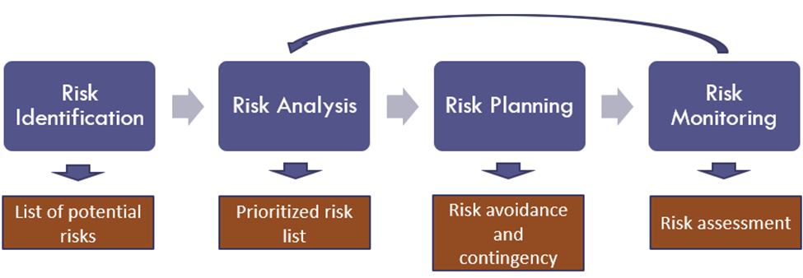

**Deliverables(Chandini)**

|  |  |
| --- | --- |
| **Item** | **Responsible Party** |
| Project Plan  PID Document | Project Manager  Project Manager |
| Project Plan, RACI | DBA |
| Requirement Types | Product Owner |
| Analysis Diagram | Lead Developer |
| User Requirements | Lead BA |
| RCT | Lead BA |
| Functional Requirements | Lead Developer |
| DB model, ER Diagrams | DBA |
| Architecture Diagrams | Lead QA |
| UML Diagrams | Product Owner |
| Test Documentation | Lead QA |
| FINAL PRESENTATION | Project Team |

**Stakeholders (assigned to Kaneshk)**

|  |  |
| --- | --- |
| **Stakeholder** | **Interest** |
| **Beauty and healthcare**  **companies** | Providing the product procurement to Flaunt. |
| **3rd party payment vendors** | Help users to use their payment gateways with added convenience by inclusion  of different payment networks(VISA, Mastercard), thus providing a hassle free experience. |
| **Customers** | Not only would they be purchasing products through our website but also help  in word-of-mouth marketing thus, helping in increasing the total foot-fall. |
| **3rd party supply chain**  **vendors** | The team will redirect the purchased orders to the supply chain vendors to  deliver them to the end user. |

This section will include a list of all known stakeholders and their interests in the project. It may be presented in the following format:

**Project Team(Tushar)**

The project team includes the following roles

* Project Manager
* Product Owner
* Lead Developer
* Lead Business Analyst
* QA Lead
* DBA
* Tester

|  |  |  |  |  |  |  |  |  |
| --- | --- | --- | --- | --- | --- | --- | --- | --- |
|  |  | **Project Roles** | | | | | |  |
| **Process Area** | **Project Tasks** | Project Manager | Product Owner | Lead Developer | Business Analyst | QA Lead | DBA | Tester |
| Project Management | Develop a project plan | A, R | C | C | C | C | C | C |
| Provide cost estimate | A, R | C | C | C | C | C | C |
| Hire resources | A, R | C | C | C | C | C | C |
| Establish a project portal on SharePoint | A, R | R | I | I | I | I | I |
| Maintain a project risk and issue log | A, R | R | C | C | C | C | C |
| Provide project status reports | A, R | R | I | I | I | I | I |
| Requirements | Perform requirements analysts | A | R | C | R | I | I | I |
| Gather business requirements | R | I | C | R | I | I | I |
| Produce functional requirements | A | I | C | R | C | I | I |
| Design | Produce high-level design specs | A | I | R | C | I | C | I |
| Produce data model | A | I | C | C | I | R | I |
| Produce detailed design specs | A | I | R | C | I | R | I |
| Coding | Establish a code repository | A | I | R | I | I | I | I |
| Develop component code | A | I | R | I | I | I | I |
| Testing | Develop a test plan | A | I | C | C | R | C | R |
| Establish a test repository | A | I | C | I | R | I | R |
| Develop test specifications | A | I | C | I | R | I | R |
| Execute testing, report defects | A | I | I | I | R | I | R |
| Conduct defect review calls | A | I | C | R | R | C | R |
| Produce, deliver defect metrics | A | I | C | R | R | I | R |
| Support test environments | A | I | R | C | C | R | C |
| Deployment | Produce a deployment plan | A | I | R | I | I | R | I |
| Produce deployment procedures | A | I | R | I | I | R | C |
| Deploy software into production | A | I | R | C | C | R | C |

**Project Plan(Sayali)**

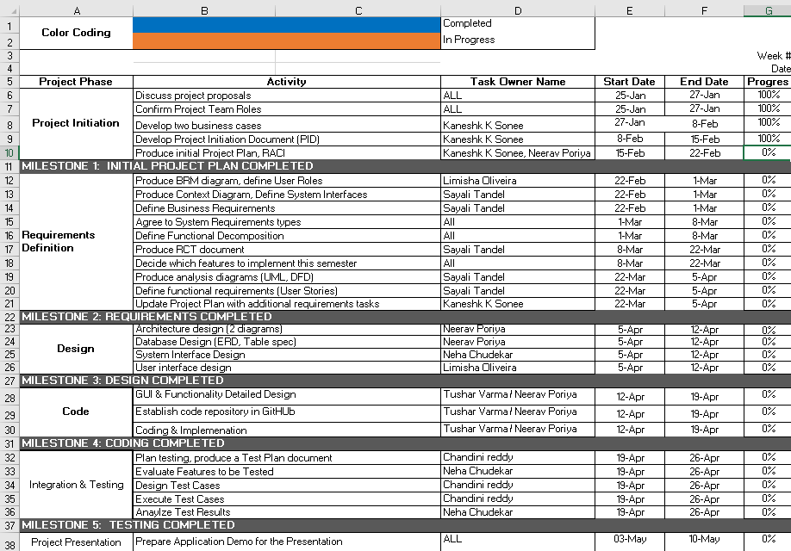

**Project Controls(Limisha)**

All project aspects will be maintained entirely in English, including communications and documents.

Official meetings will be conducted by the project manager at least twice a week, either in person or by remote video conferencing.

The meeting's objectives will be to review progress, discuss and distribute tasks between the team members, and actively collaborate on the project.

Final decisions will be made by the end of the meetings, taking into account everyone's input.

The methods of communication include Zoom for video conferencing and Slack for communicating between team members and the professor.

The project documents will be kept and shared using Google Drive for remote access and ease of editing.

**Communication Plan (assigned to Kaneshk)**

|  |  |  |  |
| --- | --- | --- | --- |
| **Stakeholder** | **Frequency** | **Type** | **Purpose** |
| **Professor** | At key stages - meetings and deliverable drafts | Email/Slack | To approve Project implementation and direction. Advise if there are any potential issues. |
| **Beauty and lifestyle**  **Brands** | At key stages | Email, phone, personal  meetings | To collaborate and  discuss the products that are to be sold on Flaunt. |
| **Project Team** | Daily | Email, Zoom for business, personal meetings, Slack | Maintain progress and ensure that the team is |
|  |  |  | meeting weekly  requirements. |
| **End Users** | Potentially during the  testing phase and after release. | FAQ section/ Email. | Feedback |